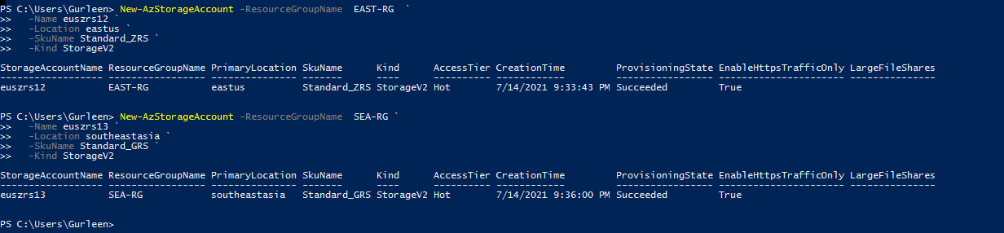

We can view the keys for each of the storage account from here:

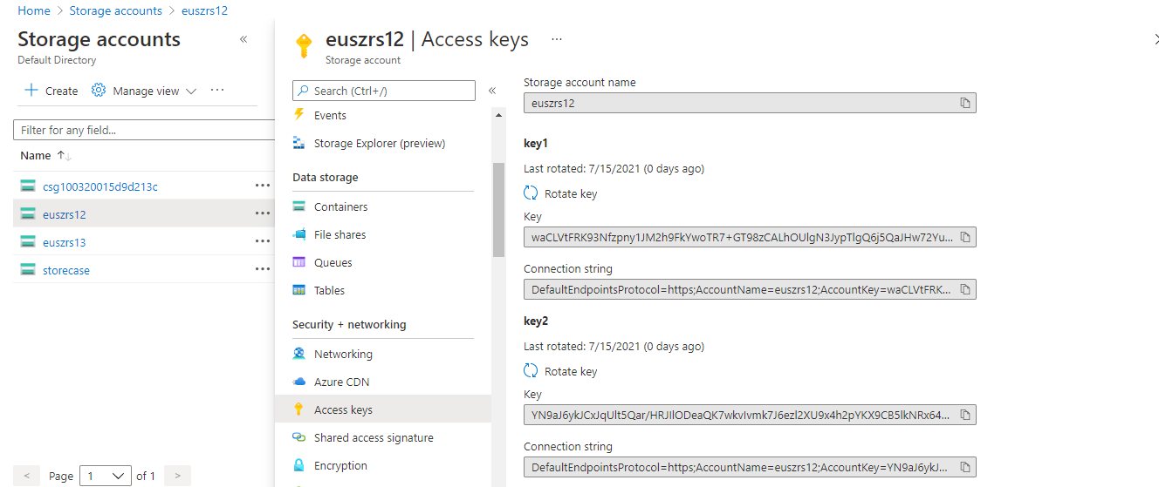

URLS:

We can check the resource types which for which we want to give SAS ( shared access signature ) and connection string

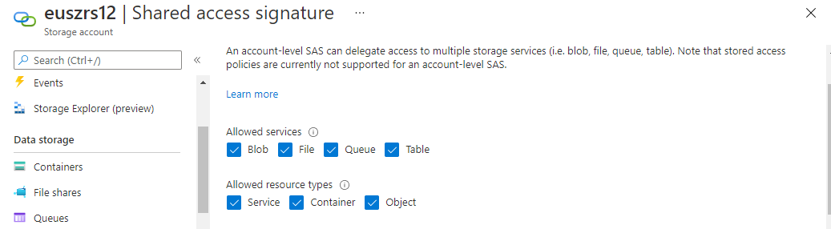

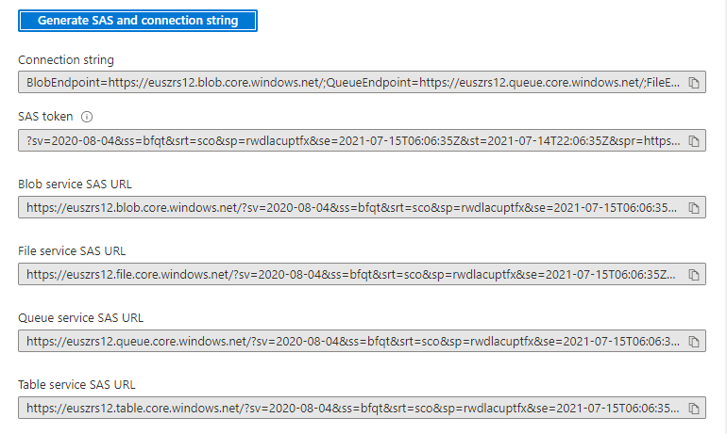

Access URL and keys can be provided.

File Share:

Created a file1

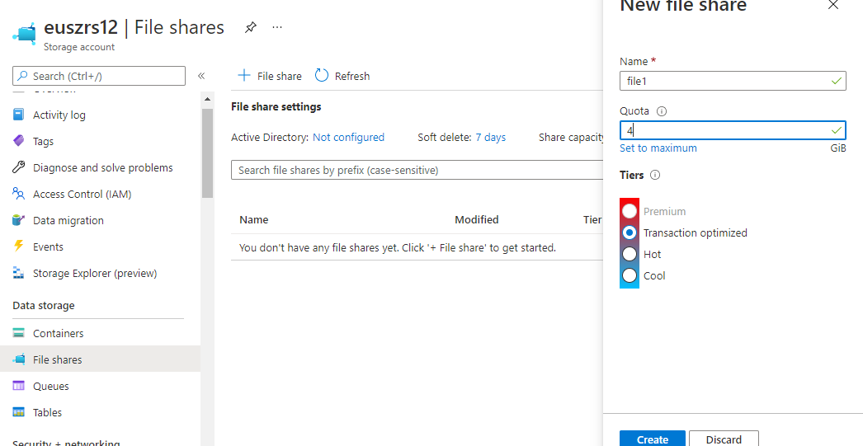

Uploaded files here on the portal :

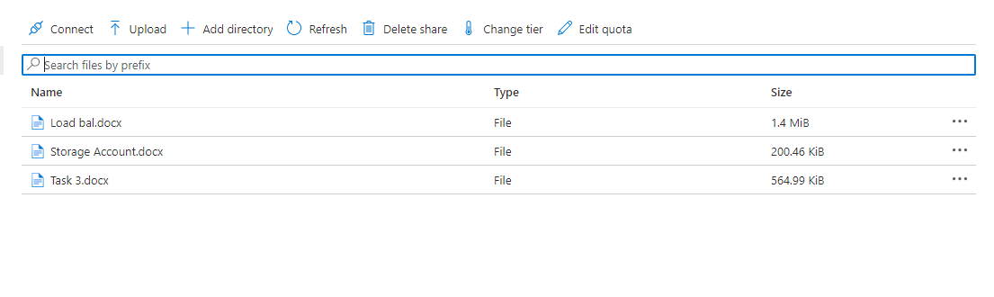

While clicking on Connect:

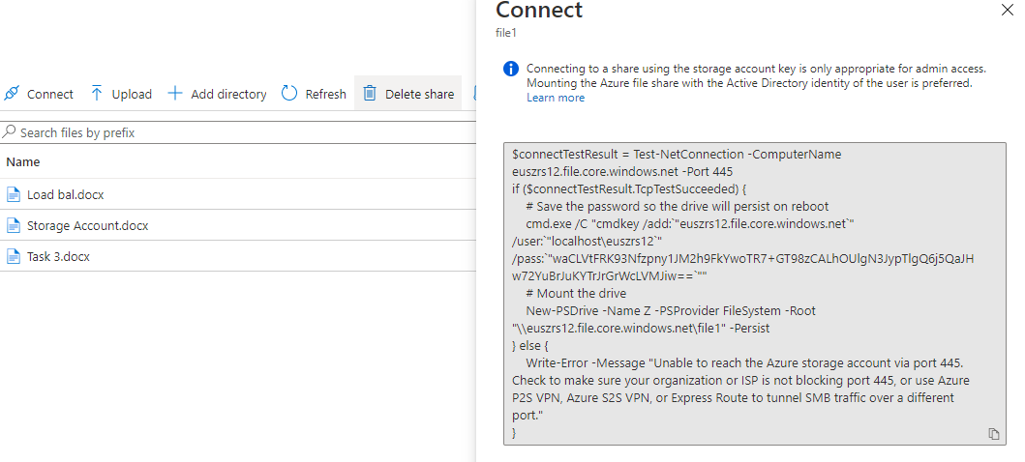

Created a drive and loaded the files in the windows Vm through powershell and appropriate access.

Copied this account key and tried running the key in powershell :

On viewing in the windows VM we can view the files uploaded in the drive mentioned by us.



